


The Holy Grail:

Cisco IOS Shellcode And
Exploitation Techniques

Michael Lynn
Internet Security Systems

© 2005 Internet Security Systems. All rights reserved. Contents are property of Internet Security Systems.
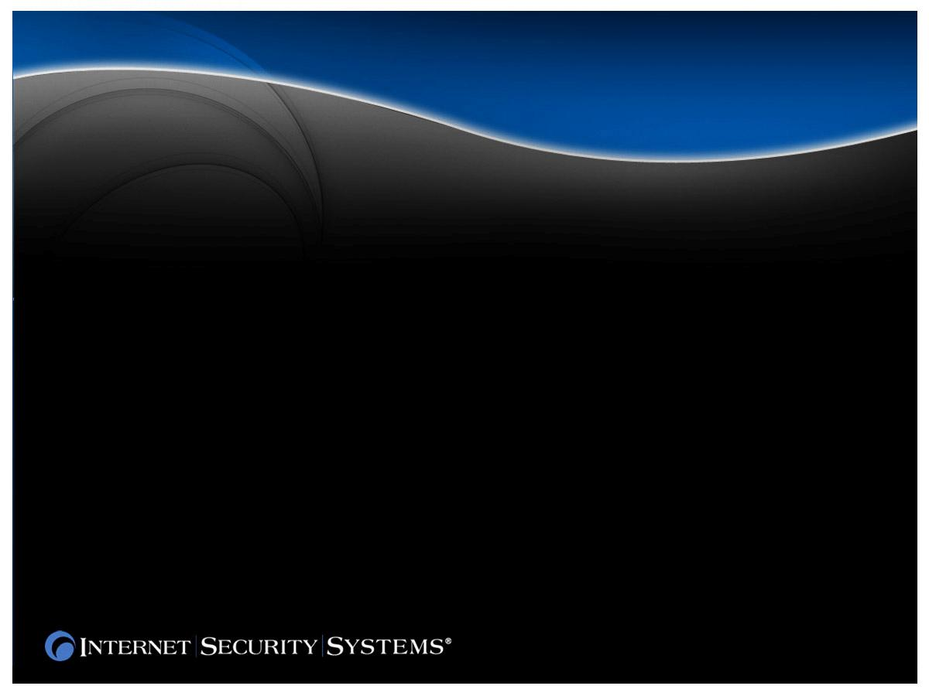


© 2005 Internet Security Systems. All rights reserved. Contents are property of Internet Security Systems.

Another Unbreakable System

■ Wide Deployment
■ Switches
■ Routers
■ Access Points

■ Keys To The Kingdom (MITM)
■ Control the network traffic
■ Packet sniff in far off lands
■ Modify traffic
■ Break weakly authenticated encryption
(passwords, etc)

© 2005 Internet Security Systems. All rights reserved. Contents are property of Internet Security Systems.

Why You Should Care

■ Stack Overflows

Some Review: Basic Techniques

■ Overwrite return address on the stack
■ Heap Overflows (Pointer Exchange)
■ Traditionally we use heap chunk linkage
■ Any linked list will do

Typical linked list delink looks like:

foo->prev->next = foo->next;
foo->next->prev = foo->prev;

© 2005 Internet Security Systems. All rights reserved. Contents are property of Internet Security Systems.

■ Routers And Switches Are Just Hardware

■ It Is Not Possible To Overflow Buffers On
IOS

■ There Is No Way To Exploit Buffer
Overflows On IOS

■ Every Router Is So Different That An
Exploit Might Work On One Router But
Never Another

© 2005 Internet Security Systems. All rights reserved. Contents are property of Internet Security Systems.

Misconceptions

■ Routers And Switches Run Software On
General Purpose CPUs

■ Buffers Do Exist And It Is Not So Rare
That They Overrun

■ Exploitation Is Possible

■ Exploitation Can Be Made Reliable And
Cross Platform (more on this later)

© 2005 Internet Security Systems. All rights reserved. Contents are property of Internet Security Systems.

Wrong!

■ Monolithic
■ No loadable modules (yet)
■ All addresses are static
■ All addresses are different per build
■ Real Time OS
■ If you are running you own the CPU (mostly)
■ We have to exit or yield properly or we will
crash
■ Once our code is running we have won any
race
■ Stability
■ IOS tends to favor rebooting over correcting
errors

© 2005 Internet Security Systems. All rights reserved. Contents are property of Internet Security Systems.

IOS Basics

■ Much Better Than Most Platforms
■ They check heap linkage
■ They are very aware of integer issues
■ They almost never use the stack
■ They have a process to check all heaps
■ Very old, very well tested code

■ Bugs Exist Anyways
■ Green pastures
■ We can get around some checks
■ We will use some of these checks
against them

© 2005 Internet Security Systems. All rights reserved. Contents are property of Internet Security Systems.

A Word On Code Quality

The Dreaded Check Heaps Process

■ Walks All Heaps Looking For Bad
Linkage
■ Even if our chunk is not freed check heaps
will detect bad linkage
■ Is run every 30 to 60 seconds depending on
load

■ This Is The Main Reason Heap Overflows
Can Be Hard

© 2005 Internet Security Systems. All rights reserved. Contents are property of Internet Security Systems.

■ Stack Overflows
■ Rare, but if we find one, its fair game
■ Heap Overflows
■ They check next and previous pointers
■ We either have to beat check heaps or not
offend it
■ We must either know the values for the
previous pointer or we must get around
this somehow
■ Monolithic Architecture
■ For heap overflows we must have exact
offsets per version (more on this later)

© 2005 Internet Security Systems. All rights reserved. Contents are property of Internet Security Systems.

Rules of Engagement
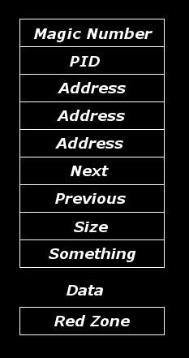

A Look At IOS Heap Structures

■ We Can’t Overflow Past Next Pointer

■ We Can’t Overwrite Magic Number
■ Magic Number is 0xAB1234BC

■ We Can’t Overwrite Red Zone
■ Red Zone value is 0xFD1001DF

© 2005 Internet Security Systems. All rights reserved. Contents are property of Internet Security Systems.

■ His Previous Presentations
■ Blackhat 2002
■ Defcon X
■ His Technique
■ Uncontrolled pointer exchange (more on this
later)
■ Flash invalidating
■ Guessing previous pointer
■ His Limitations
■ Flash invalidation trick only works against
very old routers
■ Guessing previous pointer values is usually
infeasible

© 2005 Internet Security Systems. All rights reserved. Contents are property of Internet Security Systems.

Big Ups To FX

■ Disassembly Ninjitsu

■ Lots Of Hard Work

■ Cisco Helps Us Out Some
■ Built in debugger (sort of)
■ show mem commands
■ show context
■ Forced core dumps
■ debug all
■ Finding The IOS Version
■ CDP
■ SNMP
■ Read Only Buffer Overflows

© 2005 Internet Security Systems. All rights reserved. Contents are property of Internet Security Systems.

Overcoming The Obstacles

■ Use A Core Dump Image

Getting IOS In A Disassembler

■ This will show you memory contents of the
system during runtime

■ Decompress The Firmware Image
■ Stuffit expander
■ WinRar
■ Fixup the ELF header

■ Be Prepared for IDA To Run Dog Slow

© 2005 Internet Security Systems. All rights reserved. Contents are property of Internet Security Systems.

■ Stack Overflows
■ These just work if you can find them
■ Heap Overflows
■ We need a pointer exchange
■ Its best if we can overwrite something other than
heap linkage
■ Hijack any number of callbacks
■ Using Heap Linkage
■ We can’t overflow past the next pointer
■ Maybe we could use FX’s uncontrolled pointer
exchange method for something useful

© 2005 Internet Security Systems. All rights reserved. Contents are property of Internet Security Systems.

Getting Execution

■ Overwrite Linked List In Same Chunk
■ Doesn’t clobber heap chunks
■ Take control with pointer exchange
■ Easy and reliable, but somewhat rare

■ Overwrite Linked List In Another Chunk
■ We are racing against check heaps
■ Our chunk must not be freed
■ We are racing check heaps
■ Very hard in practice unless we can deal with
check heaps

© 2005 Internet Security Systems. All rights reserved. Contents are property of Internet Security Systems.

Easy Heap Overflows

■ Racing Check Heaps
■ We have between a few seconds and a minute
to get execution or we’ll be busted by check
heaps
■ Sometimes we can trigger the unlink and force
us to win the race
■ Sometimes we can’t

■ Lets Kick Check Heaps In The Nuts
■ What if we could make check heaps go away
■ What if we could not let the router crash
■ This would greatly increase our chances of
success
■ Lets take a look at how the system crashes

© 2005 Internet Security Systems. All rights reserved. Contents are property of Internet Security Systems.

Hard Heap Overflows
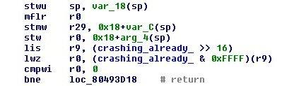

© 2005 Internet Security Systems. All rights reserved. Contents are property of Internet Security Systems.

Inside The abort() Routine

I Never Liked Check Heaps Anyways

■ Use Uncontrolled Pointer Exchange To Trick
System Into Thinking It Is Already Crashing
■ Router can no longer crash synchronously
■ Check heaps will eventually be killed due to CPU
hog watchdog
■ This Buys You A Few Minutes
■ The system will still eventually crash on an
unhandled exception anyways
■ This Gives The Potential To Exploit Arbitrary
Heap Overflows
■ After check heaps is dead it may be possible to use
uncontrolled pointer exchange to get execution
■ You can now guess previous pointer values and the
system can’t crash

© 2005 Internet Security Systems. All rights reserved. Contents are property of Internet Security Systems.

■ Memory Allocation
■ malloc
■ Process Management
■ CreateThread
■ exit
■ TTY Management
■ allocateTTY
■ Seting up a tty
■ Sockets (well, sort of)
■ TCBCreate
■ Connect

© 2005 Internet Security Systems. All rights reserved. Contents are property of Internet Security Systems.

Building The Shellcode
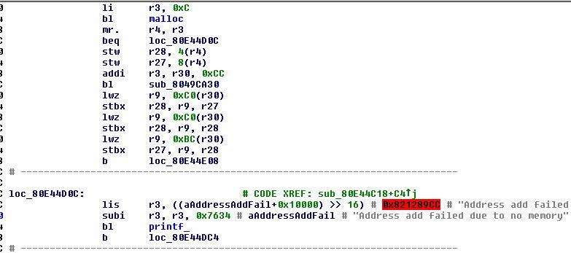

© 2005 Internet Security Systems. All rights reserved. Contents are property of Internet Security Systems.

Finding malloc()
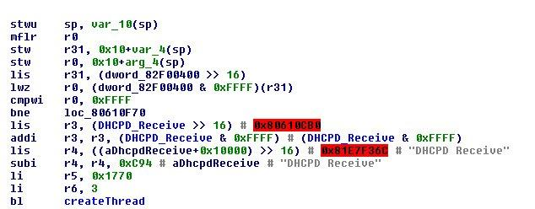

© 2005 Internet Security Systems. All rights reserved. Contents are property of Internet Security Systems.

Finding CreateThread()

Using CreateThread()

void *CreateThread(void *entryPoint,
char *name,
int something,
int dunno);

© 2005 Internet Security Systems. All rights reserved. Contents are property of Internet Security Systems.
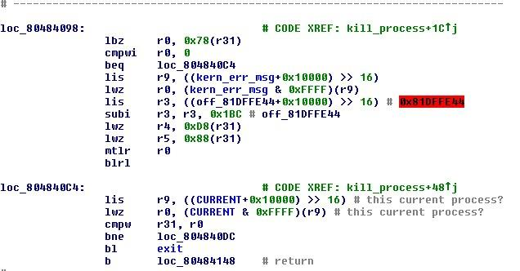

© 2005 Internet Security Systems. All rights reserved. Contents are property of Internet Security Systems.

Finding exit()
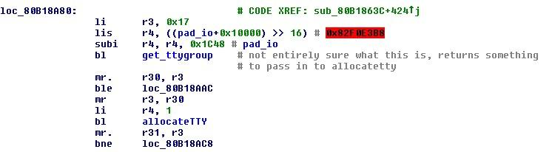

© 2005 Internet Security Systems. All rights reserved. Contents are property of Internet Security Systems.

An Example Of TTY Creation

ttygroup

Using TTY Routines

*getTTYGroup(int twentyOne, io_t *ioStruct);

tty_t
*allocateTTY(ttygroup *group, int one);

© 2005 Internet Security Systems. All rights reserved. Contents are property of Internet Security Systems.

■ Too Bad, This Is Not Unix, Its Not Even Close
■ Actually they do have BSD style sockets, they are
just never used and are not helpful to us

■ TCB’s
■ I don’t know what this stands for, and neither did
the people at Cisco I spoke with
■ This is the socket like thing we have to use
■ They seem comparable to sockets, but work in an
asynchronous way

© 2005 Internet Security Systems. All rights reserved. Contents are property of Internet Security Systems.

We Need A Socket
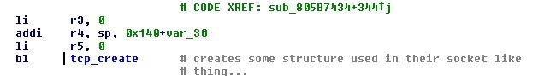

Lets See How TCB’s Are Used

© 2005 Internet Security Systems. All rights reserved. Contents are property of Internet Security Systems.
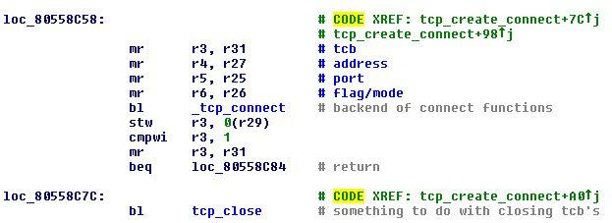

© 2005 Internet Security Systems. All rights reserved. Contents are property of Internet Security Systems.

Another Example

TCB

Using TCB Routines

*tcp_create_connect1(int zero,
short remotePort,
sockaddr *remoteAddr,
short localPort,
sockaddr *localAddr,
int *error,
int zero);

© 2005 Internet Security Systems. All rights reserved. Contents are property of Internet Security Systems.

■ Lets Cover Our Tracks
■ We could flush the logs

A Dead Process Tells No Tales

■ We could modify the log strings on the heap
■ We could sabotage the logging functions

■ Or We Could Just Kill The Logger Daemon
■ Some messages still appear on reboot, but only
to console as best I can tell

© 2005 Internet Security Systems. All rights reserved. Contents are property of Internet Security Systems.

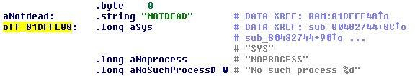

© 2005 Internet Security Systems. All rights reserved. Contents are property of Internet Security Systems.

Finding Kill

1.
2.
3.
4.
5.
6.
7.
8.
9.

Get Execution
Clean Up What We Broke
Spawn Process
Allocate And Setup TTY
Make Connect-Back TCB
Start Shell
Kill Logger Process
Exit Initial Process
World Domination

© 2005 Internet Security Systems. All rights reserved. Contents are property of Internet Security Systems.

Shellcode Check List

■ Yes And No (Mostly No)
■ Cisco is working on this

Is This The End Of The World

■ Keep your firmware images up to date and you
will probably be fine
■ Because you have to have different offset for
different firmware versions worms would be very
difficult to make

■ But Then Again
■ Stack overflows do not need to know router
versions to gain execution
■ Up coming versions of IOS use “virtual
processes” this means that offsets will be static
between firmware versions

© 2005 Internet Security Systems. All rights reserved. Contents are property of Internet Security Systems.

Questions?

© 2005 Internet Security Systems. All rights reserved. Contents are property of Internet Security Systems.

Questions?

